Question 1/4: Vectors (5 points)
Write a method void removeDuplicates() on the Vector class that traverses the vector and (in-place) removes all duplicates in it without creating or using an additional vector (or any other collections).
For example, after calling removeDuplicates() on the following vector:

[1, 2, 3, 3, 2, 4, 1]

will result in a vector containing the following elements:

[1, 2, 3, 4]

What is the time complexity of your algorithm?

Question 2/4: Trees (6 points)
A different way to store a binary search tree than the method we have seen in class, is to store all the data in a vector. Every element in the tree corresponds to a position in the array, according to a fixed rule. The root is stored in the array on position 1, and for every element stored at position i, the left child is stored at position 2*i and the right child is stored at position 2*i+1.
For instance, for the tree on the left, the corresponding vector is given on the right
0 | 1 | 2 | 3 | 4 | 5 | 6 | 7 | 8 | 9 | 10 | 11 | 12 | 13 | 14
/ | 8 | 3 | 10 | 1 | 6 |  | 14 |  |  | 4 | 7 |  |  | 13
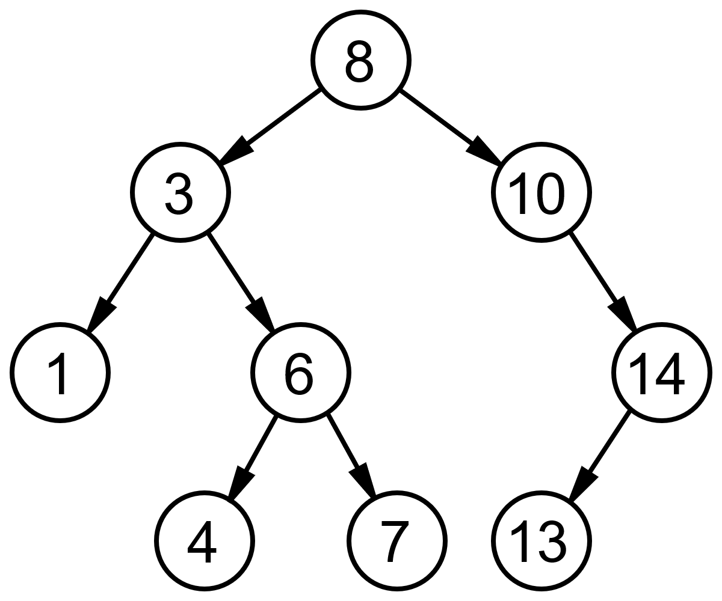

- Implement a method SetLeftChild(int index, Comparable value) which takes the index in the vector of the current node and assigns the given value to the left child.
- A method “swap” on a binary search tree mirrors the tree, i.e the left and right children are swapped. For instance, in the picture below, the tree and its swapped version are shown. Implement a method swap on a binary search tree stored in a vector as explained above. Use SetLeftChild and SetRightChild (you can assume this method exists).
- What is the time complexity of your swap method. Motivate.

Question 3/4 (4 points)
Assume a circular structure called Circular double linked list. This structure is similar to Double linked list, but the elements are chained in a circle, meaning the predecessor of the first element is the last element and the successor of the last element is the first element. Write the methods addFirst(...), addLast(), removeFirst() and removeLast().

Question 4/4: (5 points)
Consider a directed acyclic graph. A “transpose” of a graphs is the same graph, with all edges transposed, i.e. an edge from node i to node j is transposed into an edge from node j to node i. Write a transpose method on a graph in adjacency matrix representation. Motivate the time complexity of the method.

Provided Code
Vector

public class Vector {
protected Object data[];
protected int count;

public Vector(int capacity) {
data = new Object[capacity];
count = 0;
}

public int size() {
return count;
}

public boolean isEmpty() {
return size() == 0;
}

public Object get(int index) {
return data[index];
}

public void set(int index, Object obj) {
data[index] = obj;
}

public boolean contains(Object obj) {
for(int i=0;i<count;i++) {
if(data[i] == obj) return true;
}
return false;
}

public void addFirst(Object item) { … }

public void addLast(Object o) {
data[count] = o;
count++;
}

public Object getFirst() { … }

public Object getLast() { … }

public void removeLast() { .. }

public void removeFirst() { … }

}

DoubleLinkedList
public class DoubleLinkedList {
private class DoubleLinkedListElement {
private Object data;
private DoubleLinkedListElement nextElement;
private DoubleLinkedListElement previousElement;
public DoubleLinkedListElement(Object v,
DoubleLinkedListElement next,
DoubleLinkedListElement previous) {
data = v;
nextElement = next;
previousElement = previous;
if (nextElement != null)
nextElement.previousElement = this;
if (previousElement != null)
previousElement.nextElement = this;
}
public DoubleLinkedListElement(Object v) {
this(v, null, null);
}
public DoubleLinkedListElement previous() {
return previousElement;
}
public Object value() {
return data;
}
public DoubleLinkedListElement next() {
return nextElement;
}
public void setNext(DoubleLinkedListElement value) {
nextElement = value;
}
public void setPrevious(DoubleLinkedListElement value) {
previousElement = value;
}
}
private int count;
private DoubleLinkedListElement head;
private DoubleLinkedListElement tail;
public DoubleLinkedList() {
head = null;
tail = null;
count = 0;
}
public Object getFirst() {
return head.value();
}
public Object getLast() {
return tail.value();
}
public int size() {
return count;
}
public void addFirst(Object value) {...}
public void addLast(Object value) {...}
}

Binary Tree

public class Tree {

public class TreeNode implements Comparable {
protected Comparable value;
protected TreeNode leftNode, rightNode;
public TreeNode(Comparable v) {
value = v;
leftNode = null;
rightNode = null;
}
public TreeNode(Comparable v, TreeNode left, TreeNode right) {
value = v;
leftNode = left;
rightNode = right;
}
public TreeNode getLeftTree() { return leftNode; }

public TreeNode getRightTree() { return rightNode; }

public Comparable getValue() { return value; }
}
protected TreeNode root;
public Tree() {
root = null;
}
public void traverseNode(TreeNode n, TreeAction action) {
if(n != null) {
if(n.getLeftTree() != null) traverseNode(n.getLeftTree(),action);
action.run(n);
if(n.getRightTree() != null) traverseNode(n.getRightTree(),action);
}
}
public void traverseInOrder(TreeAction action) {
traverseNode(root,action);
}
public void traverse(TreeAction action){
Stack t = new Stack();
t.push(root);
while(!t.empty()) {
TreeNode n = (TreeNode)t.pop();
action.run(n);
if(n.getLeftTree() != null) t.push(n.getLeftTree());
if(n.getRightTree() != null) t.push(n.getRightTree());
}
}
}

Graph
public class Graph
{
public class Node implements Comparable
{
private Comparable info;
private Vector edges;

public Node(Comparable label)
{
info = label;
edges = new Vector();
}

public void addEdge(Edge e)
{
edges.addLast(e);
}

public int compareTo(Object o){ ... }

public Comparable getLabel()
{
return info;
}
}

private class Edge implements Comparable
{
private Node toNode;

public Edge(Node to)
{
toNode = to;
}

public int compareTo(Object o){ ... }
}

private Vector nodes;

public Graph()
{
nodes = new Vector();
}

public void addNode(Comparable label)
{
nodes.addLast(new Node(label));
}

public void addEdge(Comparable nodeLabel1, Comparable nodeLabel2)
{
Node n1 = findNode(nodeLabel1);
Node n2 = findNode(nodeLabel2);
n1.addEdge(new Edge(n2));
}
}

